# Cvičenie 07- Hrašna, Suroviak

# Experimenty s QoS mechanizmom WRED

Našou počiatočnou úlohou bolo podľa schémy zapojiť 2 routre a k nim pripojené 2 počítače podľa zadania. Podľa zadania sme ich aj nakonfigurovali a to konkrétne statické ip (statické smerovanie) pre routre aj PC, clock rate 128000, bandith 128.

**R1**

**R2**

**10.0.1.0 / 24**

**10.0.2.0 / 24**

**10.0.12.0 / 24**

**128 k**

**clock rate**

**bandwidth**

**Sender**

**Reciever, WS**

**S0**

**S0**

**f0**

**f0**

V programe D-itg sme vždy generovali 5 tokov (4x TCP, 1x UDP), postupne sme menili veľkosti tokov a sledovali sme správanie na sieti.

**Scenár 1: FIFO – všetky toky mali veľkosť 12p/s (49152b/s)**

Výsledkom bolo:

* nulová strata dát

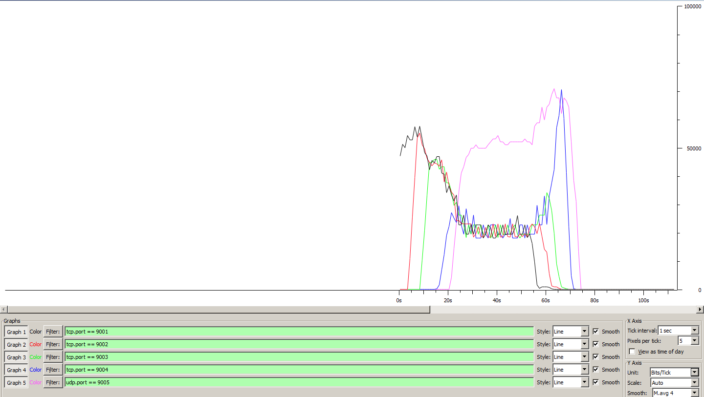

__________________________________________________________

**************** TOTAL RESULTS ******************

__________________________________________________________

Number of flows = 5

Total time = 54.690000 s

Total packets = 1592

Minimum delay = -8.399000 s

Maximum delay = -1.313000 s

Average delay = -4.523565 s

Average jitter = 0.176664 s

Delay standard deviation = 1.010889 s

Bytes received = 815104

Average bitrate = 119.232620 Kbit/s

Average packet rate = 29.109526 pkt/s

Packets dropped = 0 (0.00 %)

Average loss-burst size = 0 pkt

Error lines = 0

**Scenár 2: FIFO – všetky toky mali veľkosť 30p/s (122880b/s)**

Výsledkom bolo:

* zvýšenie stratovosti paketov na 4,63%(108 paketov) – všetky straty sú na UDP
* zvýšenie oneskorenia

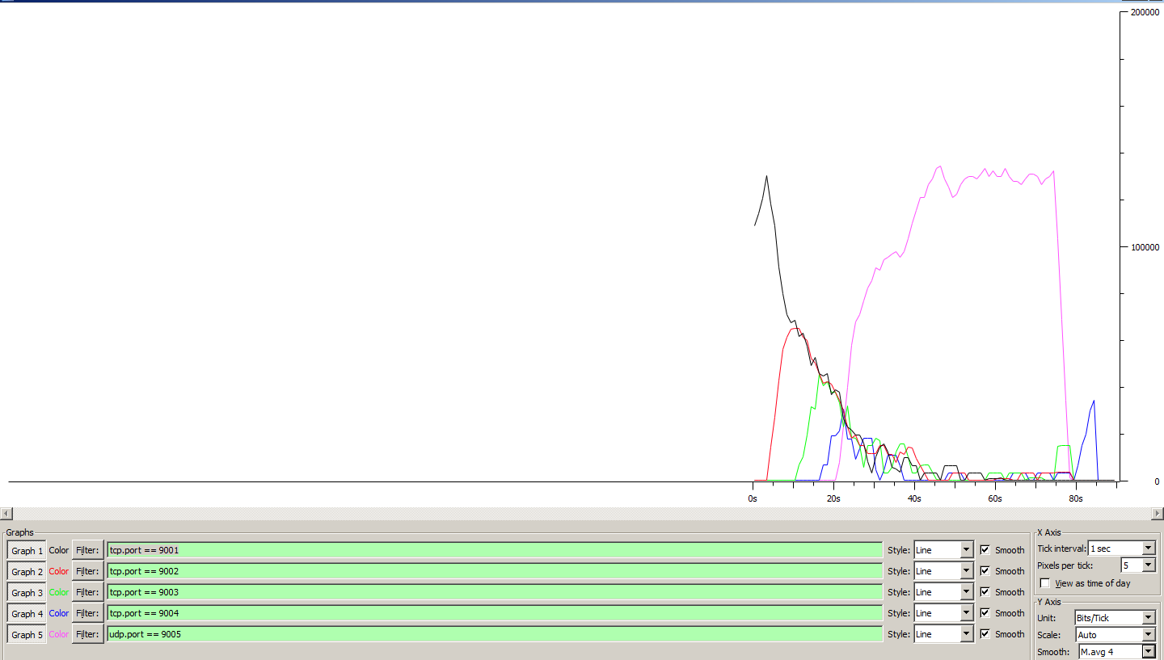

__________________________________________________________

**************** TOTAL RESULTS ******************

__________________________________________________________

Number of flows = 5

Total time = 81.965000 s

Total packets = 2226

Minimum delay = -11.417000 s

Maximum delay = 42.307000 s

Average delay = -7.097042 s

Average jitter = 0.151734 s

Delay standard deviation = 4.691777 s

Bytes received = 1139712

Average bitrate = 111.238895 Kbit/s

Average packet rate = 27.157933 pkt/s

Packets dropped = 108 (4.63 %)

Average loss-burst size = 1.687500 pkt

Error lines = 0

**Scenár 3: CBWFQ – všetky toky mali veľkosť 30p/s (122880b/s)**

Konfigurácia:

access-list 101 permit tcp any any eq 9001

access-list 102 permit tcp any any eq 9002

access-list 103 permit tcp any any eq 9003

access-list 104 permit tcp any any eq 9004

access-list 105 permit udp any any eq 9005

class-map match-all tok1

match access-group 101

class-map match-all tok2

match access-group 102

class-map match-all tok3

match access-group 103

class-map match-all tok4

match access-group 104

class-map match-all tok5

match access-group 105

policy-map zn

class tok1

set dscp af11

class tok2

set dscp af12

class tok3

set dscp af31

class tok4

set dscp af33

class tok5

set dscp af21

int fa0/0

service-policy output zn

policy-map prio

class tok1

bandwidth percent 25

class tok2

bandwidth percent 25

class tok5

bandwidth percent 25

class class-default

bandwidth percent 25

fair-queue

int s0/0/0

service-policy output prio

Výsledkom bolo:

* Veľká stratovosť 30,23% (879 paketov) – všetky straty sú na UDP

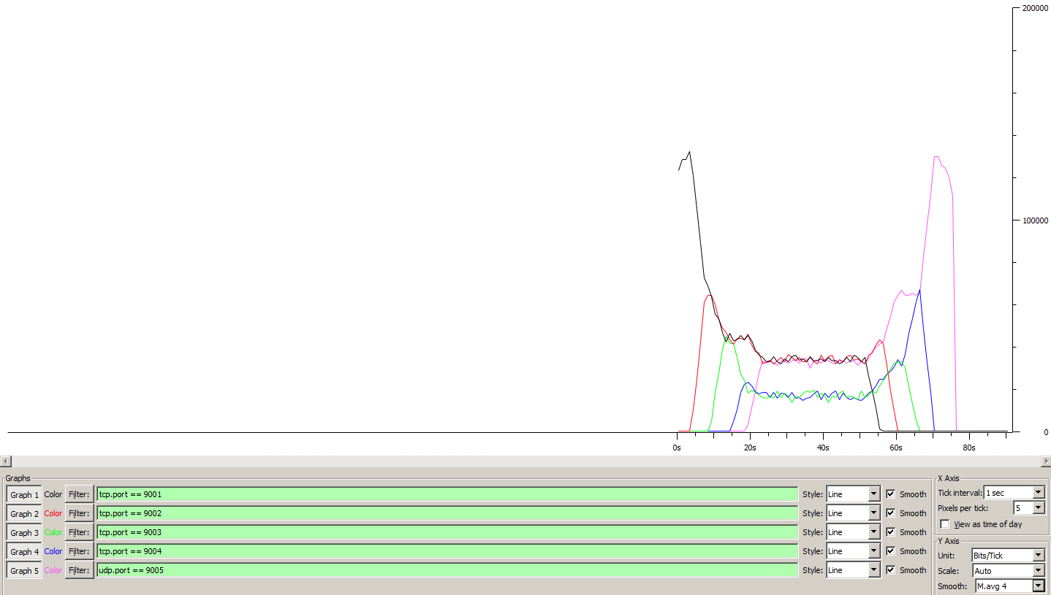

__________________________________________________________

**************** TOTAL RESULTS ******************

__________________________________________________________

Number of flows = 5

Total time = 71.556000 s

Total packets = 2070

Minimum delay = -8.479000 s

Maximum delay = 0.660000 s

Average delay = -4.614958 s

Average jitter = 0.177277 s

Delay standard deviation = 2.199587 s

Bytes received = 1059840

Average bitrate = 118.490693 Kbit/s

Average packet rate = 28.928392 pkt/s

Packets dropped = 897 (30.23 %)

Average loss-burst size = 2.921824 pkt

Error lines = 0

**Scenár 4: WRED– všetky toky mali veľkosť 30p/s (122880b/s)**

Konfigurácia:

policy-map prio

class class-default

random-detect

Výsledkom bolo:

* Veľká stratovosť 30.42% (902 paketov) – všetky straty sú na UDP

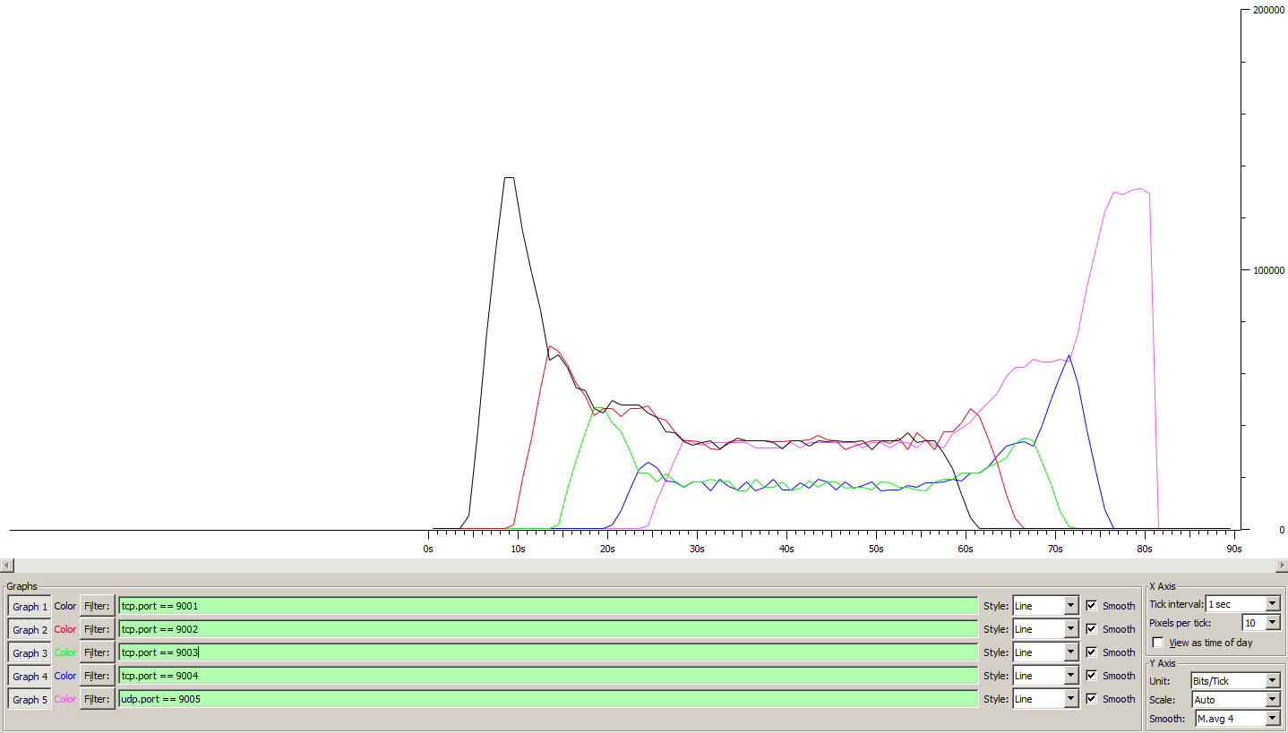

__________________________________________________________

**************** TOTAL RESULTS ******************

__________________________________________________________

Number of flows = 5

Total time = 70.937000 s

Total packets = 2063

Minimum delay = -8.983000 s

Maximum delay = 0.475000 s

Average delay = -5.172321 s

Average jitter = 0.188917 s

Delay standard deviation = 2.290464 s

Bytes received = 1056256

Average bitrate = 119.120459 Kbit/s

Average packet rate = 29.082143 pkt/s

Packets dropped = 902 (30.42 %)

Average loss-burst size = 2.891026 pkt

Error lines = 0

----------------------------------------------------------

**Scenár 5: WRED + ECN – všetky toky mali veľkosť 30p/s (122880b/s)**

Konfigurácia:

policy-map prio

class class-default

random-detect ecn

Vo windowse:

netsh int tcp set global ecncapability=enabled

Výsledkom bolo:

* Veľká stratovosť 29.63% (894 paketov) – všetky straty sú na UDP

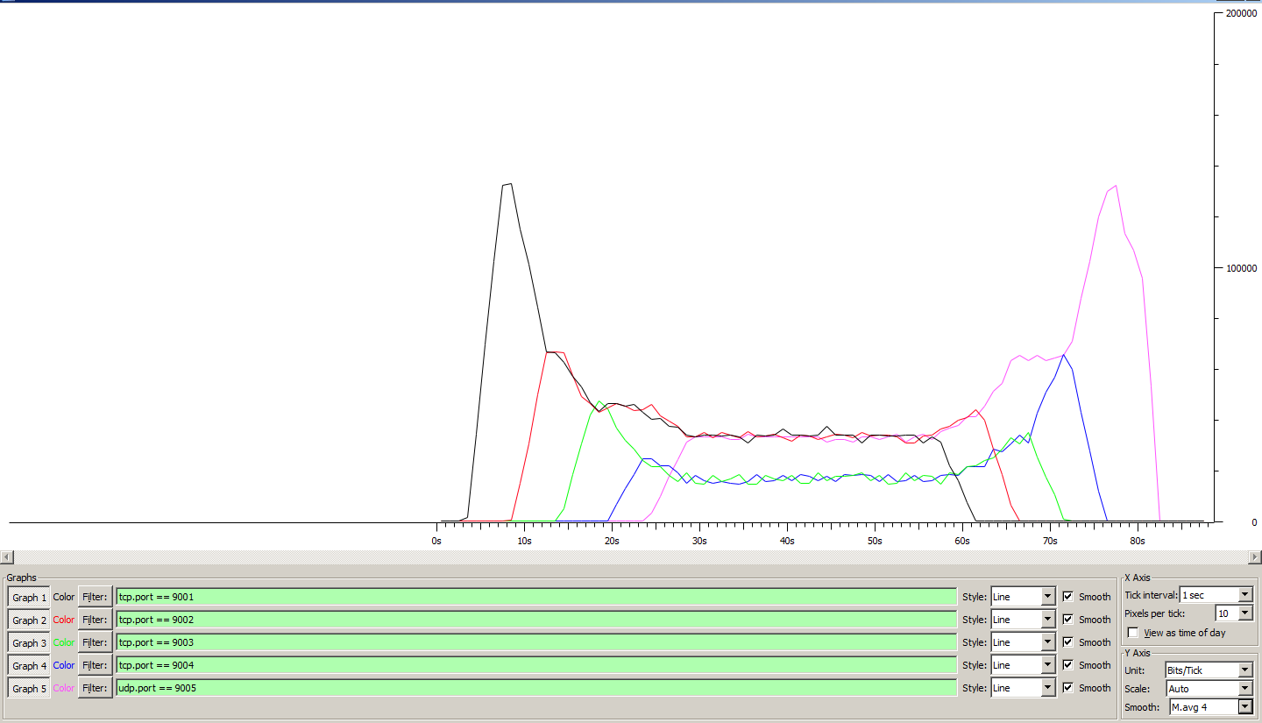

__________________________________________________________

**************** TOTAL RESULTS ******************

__________________________________________________________

Number of flows = 5

Total time = 72.396000 s

Total packets = 2123

Minimum delay = -8.173000 s

Maximum delay = 1.275000 s

Average delay = -4.364818 s

Average jitter = 0.192498 s

Delay standard deviation = 2.390109 s

Bytes received = 1086976

Average bitrate = 120.114481 Kbit/s

Average packet rate = 29.324825 pkt/s

Packets dropped = 894 (29.63 %)

Average loss-burst size = 2.865385 pkt

Error lines = 0

